<https://opentextbc.ca/biology/chapter/10-2-biotechnology-in-medicine-and-agriculture/>

**Genetic Diagnosis and Gene Therapy**

The process of testing for suspected genetic defects before administering treatment is called genetic diagnosis by genetic testing. In some cases in which a genetic disease is present in an individual’s family, family members may be advised to undergo genetic testing. For example, mutations in the ***BRCA* genes** may increase the likelihood of developing breast and ovarian cancers in women and some other cancers in women and men. A woman with breast cancer can be screened for these mutations. If one of the high-risk mutations is found, her female relatives may also wish to be screened for that particular mutation, or simply be more vigilant for the occurrence of cancers. Genetic testing is also offered for fetuses (or embryos with in vitro fertilization) to determine the presence or absence of disease-causing genes in families with specific debilitating diseases.

Gene therapy is a genetic engineering technique that may one day be used to cure certain genetic diseases. In its simplest form, it involves **the introduction of a non-mutated gene at a random location in the genome to cure a disease by replacing a protein that may be absent in these individuals because of a genetic mutation**. The non-mutated gene is usually introduced into diseased cells as part of a vector transmitted by a virus, such as an adenovirus, that can infect the host cell and deliver the foreign DNA into the genome of the targeted cell ([Figure 10.8](https://opentextbc.ca/biology/chapter/10-2-biotechnology-in-medicine-and-agriculture/#figure10.8)). To date, gene therapies have been primarily experimental procedures in humans. A few of these experimental treatments have been successful, but the methods may be important in the future as the factors limiting its success are resolved.

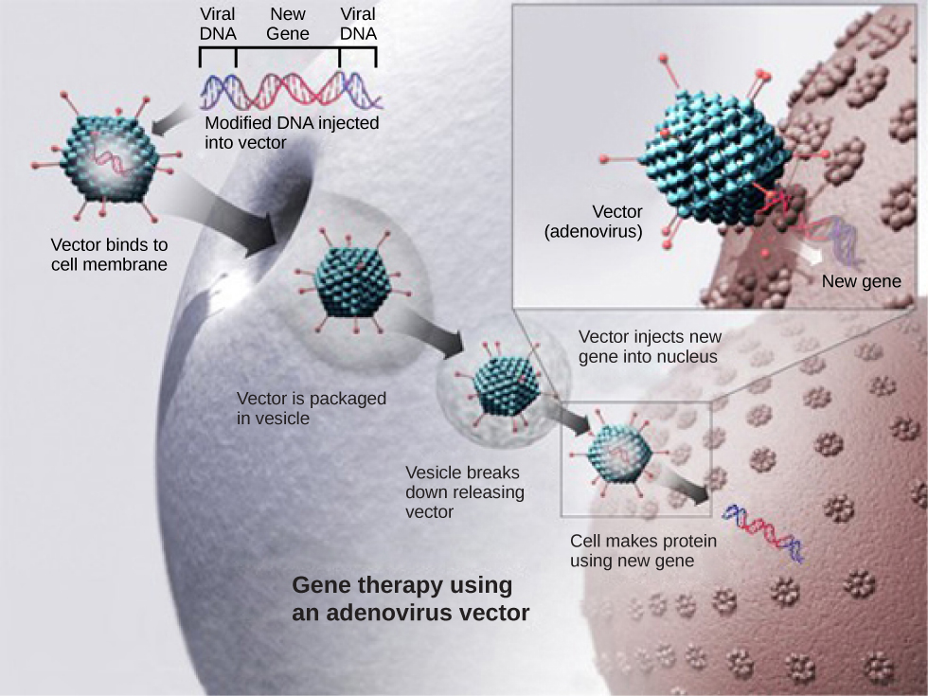

Traditional vaccination strategies use weakened or inactive forms of microorganisms or viruses to stimulate the immune system. Modern techniques use specific genes of microorganisms cloned into vectors and mass-produced in bacteria to make large quantities of specific substances to stimulate the immune system. The substance is then used as a vaccine. In some cases, such as the H1N1 flu vaccine, genes cloned from the virus have been used to combat the constantly changing strains of this virus.

Antibiotics kill bacteria and are naturally produced by microorganisms such as fungi; penicillin is perhaps the most well-known example. Antibiotics are produced on a large scale by cultivating and manipulating fungal cells. The fungal cells have typically been genetically modified to improve the yields of the antibiotic compound.

Recombinant DNA technology was used to produce large-scale quantities of the human hormone insulin in E. coli as early as 1978. Previously, it was only possible to treat diabetes with pig insulin, which caused allergic reactions in many humans because of differences in the insulin molecule. In addition, human growth hormone (HGH) is used to treat growth disorders in children. The HGH gene was cloned from a cDNA (complementary DNA) library and inserted into E. coli cells by cloning it into a bacterial vector.

<https://labiotech.eu/features/diabetes-treatment-cure-review/>

**Diabetes has become an epidemic, with over 422 million people affected worldwide sentenced to lifelong medication. Science is striving to find a cure to this chronic disease, but how close are we?**

Diabetes is the major cause of blindness, kidney failure, heart attack and stroke. The number of people affected by all types of diabetic disorders is now over four times higher than just 40 years ago. This has led the World Health Organization (WHO) to consider diabetes [an epidemic](http://www.who.int/mediacentre/factsheets/fs312/en/), predicting it will soon be the seventh biggest cause of death worldwide.

Despite its huge impact, there is still no cure for diabetes. Most treatments help patients manage the symptoms to a certain extent, but diabetics still face multiple long-term health complications.

Both type 1 and type 2 diabetes affect the regulation of insulin, a hormone required for glucose uptake in cells, resulting in high levels of blood glucose. Over time, high sugar levels deteriorate the body, especially the eyes, kidneys, heart and blood vessels.

While type 1 diabetes is an autoimmune disease that destroys the insulin-producing beta-pancreatic cells, in patients with type 2 diabetes these cells still function but the body develops insulin resistance as a consequence of genetics, obesity, highly caloric diets and lack of exercise.

The biotech industry has seen this opportunity and is striving to develop new diabetes treatments and chasing for the holy grail: a cure. Let’s have a look at what’s brewing in the field and how it will change the way diabetes is treated.

## Type 1 diabetes

### Cell therapy

Although still in the very early stages of development, cell therapy is one of the biggest hopes towards developing a cure for diabetes, especially for type 1 diabetes. Replacing the missing insulin-producing cells has the potential to recover normal insulin production and cure patients.

However, early attempts at the transplantation of pancreatic cells have largely failed, mostly due to immune reactions against donor cells that cause complications and eventually destroy the implanted cells. The lack of donors is also a limitation.

One of the most advanced alternatives comes from the Diabetes Research Institute (DRI) in the US, which is developing a bioengineered mini-organ where insulin-producing cells are encapsulated within a protective barrier. Two years ago, the DRI announced that the first patient treated in an ongoing Phase I/II trial [no longer requires insulin therapy](https://www.prnewswire.com/news-releases/diabetes-research-institutes-first-patient-in-biohub-trial-no-longer-requires-insulin-therapy-300140102.html).

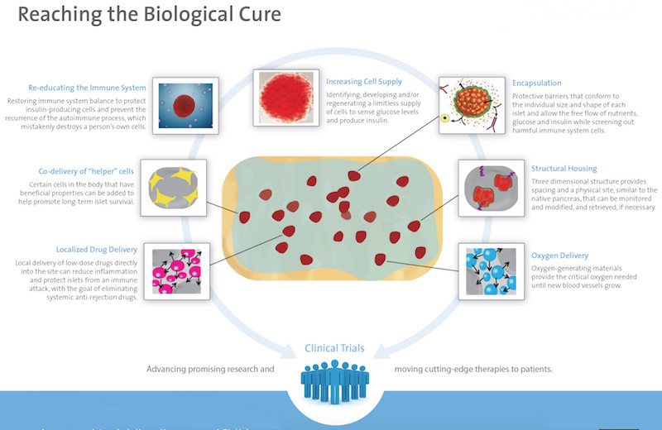

*This can be the beginning of a new era in islet transplantation. Our ultimate goal is to prevent the need for life-long anti-rejection therapy,”*stated Camillo Ricordi, Director of the DRI.

A [similar device](https://viacyte.com/products/pec%E2%80%90encap-vc-01) is being developed by Viacyte, in collaboration with the Juvenile Diabetes Research Foundation (JDRF) in the UK. After a Phase I trial where the device proved safe, the company is now working on improving the engraftment of insulin-producing cells.

Big pharma are in the early stages of developing their own cell therapy approaches for diabetes. Novo Nordisk, one of the largest providers of diabetes treatments, is bidding for stem cells and an encapsulation device, stating that the first clinical trial could take place in the “next few years.” Sanofi, also a big name in diabetes, is working with the German Evotec in a [beta cell replacement therapy](https://labiotech.eu/medical/evotec-sanofi-diabetes-cell-therapy/) for diabetics.

The Belgian Orgenesis is pursuing an approach where the implanted cells are derived from the patient’s liver and reprogrammed into insulin-producing cells to avoid the issues of sourcing cells from donors. Islexa, in the UK, is developing a similar procedure sourcing cells from the pancreas.

Although the promises are big, these technologies are still far from the market. First, clinical trials will have to show they do work. Then, the price could be steep, as cell therapy precedents for other applications, such as oncology, come with price tags that reach the six figures and are finding difficulties to get reimbursed. Considering that compared to cancer, diabetes is not an immediately life-threatening disease, health insurers in some countries might be reluctant to cover the treatment.

### Countering the immune system

In type 1 diabetes, insulin-producing cells are progressively destroyed until none are left and the patient fully depends on insulin injections. Stopping the progression of the disease early in the process could preserve the cells and provide a cure for patients diagnosed early enough.

That is the goal of Imcyse, a French company [running a clinical trial](https://labiotech.eu/medical/imcyse-diabetes-immunotherapy-cure/) with an immunotherapy designed to stop type 1 diabetes. Patients that have been diagnosed within the last 6 months, who still retain some insulin-producing cells, are given a treatment designed to make the immune system destroy the specific immune cells that are attacking insulin-producing cells. Results are expected later this year and will reveal whether the treatment has the potential to become a cure.

ActoBio Therapeutics, in Belgium, is about to start another clinical trial with an unusual approach to stop type 1 diabetes. The company uses cheese-producing bacteria to deliver two drugs that stimulate regulatory T cells to instruct the immune system not to attack insulin-producing cells.

Also getting close to the clinic is Neovacs, developing [a vaccine for type 1 diabetes](https://labiotech.eu/medical/neovacs-vaccine-diabetes-type-1/) intended to delay the progression of type 1 diabetes after an early diagnosis. The treatment is focused on lowering the levels of an inflammatory protein that is thought to be involved in multiple autoimmune diseases, including type 1 diabetes but also lupus.

### The artificial pancreas

Efforts to cure or stop type 1 diabetes are still in the early stages, and these approaches will also not be suitable for people that have already lost their insulin-producing cells. A solution could be the creation of an “artificial pancreas” — a fully automated system that can measure glucose levels and inject the right amount of insulin into the bloodstream, just like a healthy pancreas would.

“*Diabetes type 1 is very different from your standard disease. Insulin requirements vary greatly from one day to another and there is no way patients can know what they need,”*Roman Hovorka, Professor at the University of Cambridge, explained to me during [an interview](https://labiotech.eu/artificial-pancreas-roman-hovorka-diabetes/)*.*His research group is working on the development of an algorithm that can accurately predict insulin requirements for a specific patient at any moment.

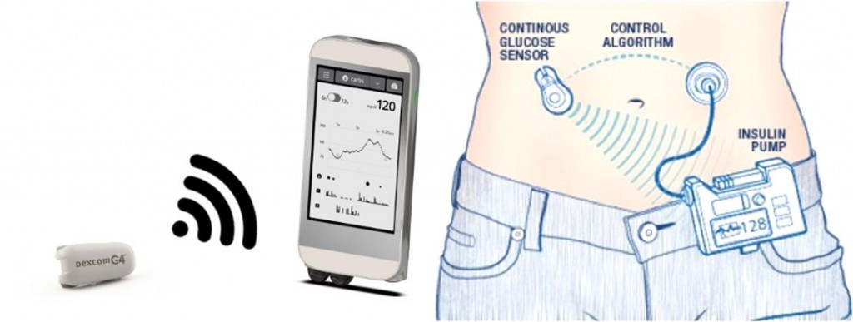

Replacing humans with computers could make patients better control their sugar levels and suffer less complications in the long term. The French company Cellnovo has already shown that just a partially automated system, where blood sugar levels can be monitored wirelessly but patients still select insulin amounts, can [reduce the chances](https://labiotech.eu/tops/top-medical-device-companies-europe/) of reaching life-threatening low sugar levels up to 39%. The company is now working towards developing a fully automated artificial pancreas in collaboration with Imperial College, the Diabeloop consortium and the Horizon2020 program.

## Type 2 diabetes

### Inducing insulin production

*“During the past decade over 40 new pills and injections were approved for diabetes. However, the scary reality is that the majority of patients with type 2 diabetes still have poor glycemic control,”*stated Kurt Graves, CEO of Intarcia, in a [press release](http://www.prnewswire.com/news-releases/intarcia-submits-new-drug-application-nda-to-fda-for-us-marketing-approval-of-itca-650-in-type-2-diabetes-300366473.html).

One of the biggest hits in type 2 diabetes treatment is glucagon-like peptide (GLP)-1 receptor agonists, which induce insulin production in beta-pancreatic cells while suppressing the secretion of glucagon. All big pharma have GLP-1 drugs on the market or their pipelines, including [Sanofi](https://labiotech.eu/medical/zealand-pharma-sanofi-suliqua/), Eli Lilly, Roche, AstraZeneca and [Boehringer Ingelheim](https://labiotech.eu/medical/boehringer-ingelheim-zealand-diabetes/). But Novo Nordisk is going a step further with the [first oral version of a GLP-1 drug](https://labiotech.eu/medical/oral-glp-1-diabetes-treatment/), which is now close to the market.

The French company Poxel is going after [a different approach](https://labiotech.eu/medical/poxel-imeglimin-diabetes-phase-iib/) with a drug that simultaneously targets the pancreas, the liver and the muscles, where it helps recover the lost function of mitochondria, which is thought to drive the progression of type 2 diabetes.

In Sweden, Betagenon and Baltic Bio are working on [a first-in-class drug](https://labiotech.eu/medical/type-2-diabetes-betagenon/) with the potential to simultaneously control sugar levels and reduce blood pressure, a big risk factor in patients with type 2 diabetes who are also obese.

Tackling the obesity component of type 2 diabetes is also the German Morphosys, which is [running Phase II trials](https://labiotech.eu/medical/morphosys-novartis-type-2-diabetes/) with an antibody designed to reduce fat, prevent insulin resistance and control excessive eating.

### The microbiome

Just in the past decade, scientists have realized the big role that the microbes living inside and on us play in our health. The human microbiome, and especially the gut microbiome, has been found to be [linked to multiple chronic diseases](https://labiotech.eu/features/microbiome-research-review/), including diabetes.

An unbalanced microbiome composition, known as dysbiosis, has been found in patients with diabetes, for whom the diversity of the gut microbiome is often reduced as compared to healthy people. Researchers from the University of Amsterdam recently showed that fecal transplants, used to transfer the microbiome of a healthy person to the gut of one with diabetes, can result in a [short-term improvement](https://labiotech.eu/medical/diabetes-fecal-transplant-netherlands/) of the insulin resistance found in obese patients with type 2 diabetes.

Some companies are now starting taking the concept into a treatment, with the French Valviotis currently [conducting preclinical testing](https://labiotech.eu/medical/valbiotis-gut-microbiome-diabetes/) of a drug aimed at increasing the microbiome diversity as a treatment for diabetes.

Although promising, the microbiome field is very young and its complexity makes it difficult to establish causation after finding correlation. Until more diabetes treatments are tested in the clinic, it will be difficult to determine the real potential of the microbiome in this space.

## The needle-free revolution

*“In a perfect world, blood sugar testing would be quick and painless,”*said Avner Gal, CEO of Integrity Applications in an [interview](http://www.medgadget.com/2013/10/non-invasive-measurement-of-blood-glucose-levels-using-glucotrack-interview.html). That world may not be so far away, as many companies are developing non-invasive methods to substitute finger pricking.

Gal’s company, Integrity Applications, has developed a device called [GlucoTrack](http://www.integrity-app.com/the-glucotrack/) that can measure glucose using electromagnetic waves and is already available in Europe.

Similar technologies are popping up, with GlucoSense in London using laser light to measure sugar levels and MediWise making use of radio waves. ”*The device could reduce costs for healthcare, which in the case of diabetes account for €90Bn* *a year in Europe,”*MediWise co-founder Panos Kosmas told us in an [interview](https://labiotech.eu/interviews/glucowise-interview-needle-free-diabetes/)*.*

Patches are also becoming a popular form of measuring blood glucose without needles, such as [FreeStyle Libre](http://www.freestylelibre.co.uk/), an inch-wide patch that can be worn for up to 2 weeks. At the University of Bath, researchers are developing [a graphene patch](https://labiotech.eu/medical/diabetes-needle-free-blood-sugar-testing/) that could provide greater accuracy by measuring sugar levels individually in multiple hair follicles.

Others are going for implants, such as NovioSense’s eye implant or Senseonic’s subcutaneous device, which will be distributed by Roche.

Still, non-invasive options to measure blood sugar often face issues regarding accuracy. The famous glucose-measuring contact lens that Google announced in 2014 [was dismissed as “technically infeasible”](https://labiotech.eu/features/contact-lens-glucose-diabetes/) and further developments will be needed to reach the degree of accuracy of finger-pricking methods.

## What’s next in diabetes treatment?

The diabetes market is expected to reach a massively big €86Bn by 2025 combining both type 1 ([€32Bn](http://www.prnewswire.com/news-releases/diabetes-devices-market-size-to-reach-355-billion-by-2024-grand-view-research-inc-581485851.html)) and type 2 (€54Bn) treatments, and we can expect all sort of revolutionary technologies to come forward and claim their market share. Researchers are already speculating about [microchips](https://med.stanford.edu/news/all-news/2014/07/researchers-invent-nanotech-microchip-to-diagnose-type-1-diabete.html)that can diagnose diabetes type 1 before the symptoms appear or [nanorobots](https://www.ncbi.nlm.nih.gov/pubmed/18455965) traveling in the bloodstream while they measure glucose and deliver insulin.

“There’s little fiction left in this. I strongly believe that microrobotics will come and will be part of our drug delivery within the next 10 years,” said **Tomas Landh**, Director of Strategy and Innovation Sourcing at Novo Nordisk, at the [2013 Medicon Valley Alliance Annual Meeting](https://vimeo.com/82939397)

<https://pharmacyte.com/live-cell-encapsulation/diabetes/>

**The Diabetes Epidemic**

Diabetes hs reached epidemic proportions globally. In its 2016 Global Report on Diabetes, the World Health Organization (“WHO”) estimated that 422 million people worldwide have the disease – 314 million more than in 1980. Approximately 8.5% of adults worldwide have diabetes. Approximately $920 billion is spent annually in the treatment of diabetes and related healthcare. Approximately 10% of every healthcare dollar is estimated to be spent on care for people with diagnosed diabetes. Approximately 30 million people in the U.S. have diabetes. About $615 million are spent annually in the treatment of diabetes alone. The worldwide market for diabetes treatment has been projected to reach $650 billion by 2020.

**Diabetes**

Diabetes is caused by insufficient availability of, or resistance to, insulin. Insulin is produced by the islet cells of the pancreas. Its function is to assist in the transport of sugar in the blood to the inside of most types of cells in the body where it is used as a source of energy for those cells. In Type 1 diabetes the islet cells of the pancreas have been destroyed – usually by an autoimmune reaction. Type 1 diabetics require daily insulin administration through injection or through the use of an insulin pump. In Type 2 diabetes the body does not use insulin properly. This means the body has become resistant to insulin. Type 2 diabetes can generally be controlled by diet and exercise in its early stages. As time goes by, it may be necessary to use antidiabetic drugs to control the disease. However, over time these too may lose their effectiveness. Thus, even Type 2 diabetics may become insulin-dependent.

**Efforts to Cure Diabetes**

In an effort to “cure” Type 1 diabetes, replacement of damaged pancreatic islet cells has been attempted. This involves transplantation of the entire pancreas or of its beta islet insulin-producing cells. In 2000, islet cells from human cadavers were transplanted into 7 insulin-dependent diabetics in a clinical trial carried out in Edmonton, Canada. The procedure was known as the “Edmonton Protocol.” Each patient enrolled remained insulin-independent for one year. But because of the high doses of immune-suppressive drugs that must accompany such transplantations, patients were placed at high risk of infection and even cancer. These drugs have serious side effects and have required patients to cease treatment with them. Worldwide, less than 1,000 people with Type 1 diabetes are known to have been transplanted with pancreatic islets from another human.

Attempts to avoid the use of islet cells from human donors, have led to islet cells from pigs being used. This type of interspecies transplantation is known as xenotransplantation. Drug regulatory authorities have shown resistance in approving the use of such interspecies transplantations. In addition, there are problems besides regulatory approval, the foremost of which is an attack by the body’s immune system on the transplanted cells. To protect the non-human cells from attack by the immune system of the human being, they have been encapsulated using other forms of encapsulation technology than we use. In those studies, the transplanted islet cells from pigs were surrounded by a s capsule typically made of alginate (a derivative of seaweed).

However, to translate this concept into a viable treatment for Type 1 diabetes, researcher’s efforts have been plagued by poor survival of the transplanted islet cells. In addition, the integrity of capsules composed of alginate has been shown to degrade over time. This then allows for immune system attack on the transplanted pig islets and necessitates additional transplantations. Also, as the alginate “capsules” degrade, they can elicit an immune response.

Different tubular and planar “chamber-type” immune-protective devices that contain islet cells are under development by other companies. These devices are placed in the body where they can be retrieved and replaced when necessary. Tubular chambers have shown good biocompatibility, but they are subject to rupture, exposing the islets to immune system attack. They also require large numbers of islet cells. Planar chambers are more stable, but they can cause extensive foreign body reactions in the host resulting in fibrotic overgrowth and thus transplant failure.

The most extensively researched immune-protective strategy is that which employs microcapsules. They are relatively simple to manufacture, can be implanted into the body without major surgery and, depending on the nature of the encapsulation material, micro-encapsulated cells can be cryopreserved. Micro-encapsulated islet cells first made their appearance in 1994 when a diabetic patient, already receiving immunosuppressive drugs, was transplanted with these cells encapsulated in alginate and remained insulin-independent for 9 months. However, 22 years and numerous clinical trials later, there are still no reports of long-term insulin-independence in non-immune-suppressed diabetic patients receiving encapsulated pancreatic islet transplants.

**Bio-Artificial Pancreas for Diabetes**

We plan to develop a therapy for Type 1 diabetes and insulin-dependent Type 2 diabetes. Our therapy involves encapsulation of human cells that have been genetically engineered to produce, store insulin and release insulin on demand at levels in proportion to the levels of blood sugar (glucose) in the human body. We also plan to explore the encapsulation of human stem cells and beta islet cells as an alternative to using genetically modified human liver cells. The encapsulation will be done using the Cell-in-a-Box® technology.

Insulin-producing cells (HIT-T15) have already been encapsulated using the sodium cellulose sulfate-based technology found in Cell-in-a-Box®. Encapsulation did not affect cell viability or insulin production. In cell culture, the encapsulated cells were able to detect the glucose concentration in a nutrient solution and react in a proper way by producing insulin. In the opinion of the authors of the study, encapsulation of insulin-producing cells with sodium cellulose sulfate, which is more biocompatible and less immunogenic than other encapsulation materials, seemed to be a promising method for the immunoisolation of porcine beta islet cells for xenotransplantation to replace the endocrine pancreas. Schaffellner S., et al.  
*Transplantation Proc., Vol. 37, 248-252 (2005)*

In an effort to avoid the use of non-human islet cells in its diabetes treatment, PharmaCyte has obtained from the University of Technology Sydney (“UTS”) in Australia an exclusive, worldwide license to use insulin-producing genetically engineered human liver cells developed by UTS to treat Type 1 diabetes and insulin-dependent Type 2 diabetes. These cells, named “Melligen,” have already been tested in mice and shown to produce insulin in direct proportion to the amount of glucose in their surroundings. In fact, when Melligen cells were transplanted into immosuppressed diabetic mice, their blood glucose levels became normal. The Melligen cells reversed the diabetic condition.

Melligen cells can be readily grown in culture and are available in unlimited supply. Compared to native pancreatic beta islet cells, Melligen cells are much more resistant to the pro-inflammatory cytokines that have been shown to be involved in beta islet cell death. We believe that this property makes them an ideal potential candidate cell line for beta islet cell replacement therapy with the prospect to achieve long-term transplant graft function. However, further research and development (“R&D”) needs to be done with the Melligen cells to insure they function as reported in the literature by UTS.

PharmaCyte has acquired from Austrianova an exclusive, worldwide license to use the Cell-in-a-Box® technology for the development of a treatment for diabetes. We believe that encapsulating the Melligen cells using Cell-in-a-Box® live cell encapsulation technology has numerous advantages over encapsulation of cells with other materials, such as alginate. Since our capsules are composed largely of cellulose (a bio-inert material in the human body), the Cell-in-a-Box® capsules are durable, resilient and long-lasting when compared to the competition. They remain intact for long periods of time in the body, all the while protecting the cells inside them from immune system attack. Also, in prior studies these capsules and the cells inside them have not caused any immune or inflammatory responses like those seen with alginate-encapsulated cells. Studies have shown that the Cell-in-a-Box encapsulation process does not reduce the capability of the Melligen cells to produce insulin.

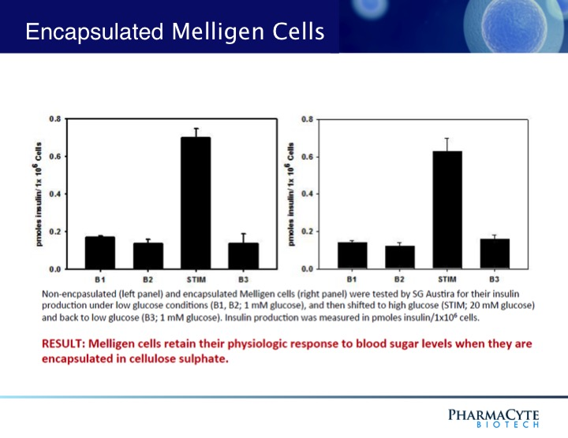

We believe that the combination of the Melligen cells and the Cell-in-a-Box® encapsulation technology could lead to a breakthrough therapy for Type 1 diabetes and insulin-dependent Type 2 diabetes. Encapsulating the Melligen cells could enable us to overcome all of the past problems in developing a true bio-artificial pancreas. Members of our International Diabetes Consortium (see under “Company” tab), are working in concert to develop our therapy for insulin-dependent diabetes.

<https://www.sigmaaldrich.com/technical-documents/articles/biology/cell-in-a-box.html>

# Cell-in-a-Box®

## Introduction

The Cell-in-a-Box technology from Austrianova enables one to encapsulate cells in a protective, semipermeable, cellulose based, 2 mm bead. Small pores in the beads allow for nutrient and waste product exchange, but retain the cells within the beads. The beads are durable, do not elicit an immune response from the host and can withstand up to 6 months in an implant. These characteristics allow embedded cells to grow for longer periods than in traditional 2D cell culture. This technology has already been used successfully in novel research and clinical applications covered in over 40 international peer reviewed publications.

To bring this technology to a wider research audience, we worked with Austrianova to develop the [**Cell-in-a-Box Kit**](https://www.sigmaaldrich.com/ProductLookup.html?ProdNo=CIB001&Brand=SIGMA) (Catalog No. [**CIB001**](https://www.sigmaaldrich.com/ProductLookup.html?ProdNo=CIB001&Brand=SIGMA)). This kit allows researchers to quickly and easily encapsulate their own cells for further study.  The steps required in the kit are simple and straightforward.

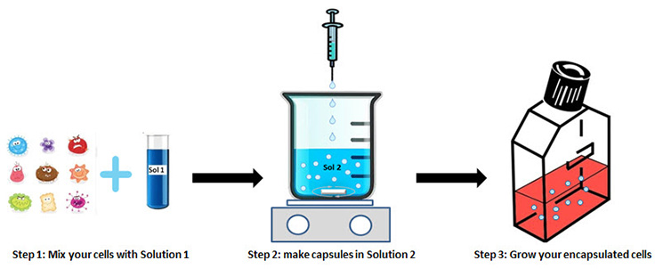

The result of this simple procedure can be seen below.

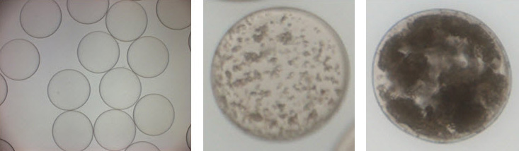

Encapsulated cells; left: empty capsules; middle: capsule with cells inside directly after encapsulation; right: capsules after culturing for days or weeks (depending on cell growth speed).

## Proven Applications

With over 40 peer reviewed publications the Cell-in-a-Box technology has shown great promise in the areas of cancer, diabetes and drug delivery research[**1-7**](https://www.sigmaaldrich.com/technical-documents/articles/biology/cell-in-a-box.html#ref).  For example, in cases of localized cancerous tumors it is desirable to deliver localized treatment. To affect a localized treatment for pancreatic cancer, Cell-in-a-Box encapsulated cells were placed, using supraselective catheterisation, into blood vessels leading to the tumor[**1**](https://www.sigmaaldrich.com/technical-documents/articles/biology/cell-in-a-box.html#ref). These cells locally converted a chemotherapeutic prodrug to its tumor toxic form. This treatment improved the 1 year survival rate from 11% to 36%. This localized treatment research is ongoing and may result in significant improvements in the treatment of pancreatic cancer.

In diabetes research there have been attempts to implant islet of Langerhans cells into diabetic hosts, an approach that leads to problems suppressing the resulting graft vs. host reaction. Cell-in-a-Box encapsulated cells are protected from graft vs. host reactions and a number of experiments have been undertaken to prove the efficacy of the technology. Encapsulated islets of Langerhans cells were shown to react to changes in glucose levels in the environment and excrete insulin to the environment[**2**](https://www.sigmaaldrich.com/technical-documents/articles/biology/cell-in-a-box.html#ref). In subsequent experiments, implanted islet cells from pigs were show to control blood glucose levels in the rats for over 6 months[**3**](https://www.sigmaaldrich.com/technical-documents/articles/biology/cell-in-a-box.html#ref).

## Potential Applications

The Cell-in-a-Box Kit is designed to encapsulate your cell of choice in cellulose beads for superior and extended growth levels, providing a protective growth environment for cells. Because of this, the potential applications for this kit in research are extensive; this kit opens up opportunities for unique analyses of how host environments and your cells interact, both *in vitro* and *in vivo*. An example of an *in vitro* application for this kit is in bioreactors. Encapsulated cells are insulated from destructive shear forces found in bioreactors, allowing for the expression of antibodies and recombinant proteins for longer periods of time, improving productivity.

Whatever the intended application, these are the key properties to keep in mind.

**Key Properties**

* Cellulose-based
* Durable (can last for years in vivo)
* Artificial and semipermeable
* Biocompatible
* Useful for a wide variety of cell types
* Longer cell survival periods
* Encapsulated cells can be frozen and stored

The Cell-in-a-Box Kit is designed to simply and reproducibly encapsulate a wide variety of cells for further study. As has been discussed, there are already several proven applications for this technology, and we are confident that as this kit is used by more researchers that many additional novel applications for this technology will arise.

<https://www.medicalnewstoday.com/articles/323865.php> converting liver cells into beta cells and inserting in a capsule

<https://www.technologyreview.com/s/613001/doctors-plan-to-test-a-gene-therapy-that-could-prevent-alzheimers-disease/>

<https://www.alzdiscovery.org/news-room/blog/gene-therapy-a-new-frontier-in-alzheimers>